

Semester Two Examination, 2021
Question/Answer booklet

MATHEMATICS
SPECIALIST
UNITS 1&2

SOLUTIONS
Section One:
Calculator-free
WA student number: In figures

In words

Your name

Number of additional
answer booklets used
(if applicable):

Time allowed for this section
Reading time before commencing work: five minutes
Working time: fifty minutes

Materials required/recommended for this section
To be provided by the supervisor
This Question/Answer booklet
Formula sheet

To be provided by the candidate
Standard items: pens (blue/black preferred), pencils (including coloured), sharpener,
correction fluid/tape, eraser, ruler, highlighters

Special items: nil

Important note to candidates
No other items may be taken into the examination room. It is your responsibility to ensure that you do not have any unauthorised material. If you have any unauthorised material with you, hand it to the supervisor before reading any further.

Structure of this paper

Section | Number of  questions  available | Number of  questions to  be answered | Working  time  (minutes) | Marks  available | Percentage  of  examination
Section One:  Calculator-free | 8 | 8 | 50 | 50 | 35
Section Two:  Calculator-assumed | 13 | 13 | 100 | 92 | 65
 |  |  |  | Total | 100

Instructions to candidates

1. The rules for the conduct of examinations are detailed in the school handbook. Sitting this examination implies that you agree to abide by these rules.

2. Write your answers in this Question/Answer booklet preferably using a blue/black pen.
Do not use erasable or gel pens.

3. You must be careful to confine your answers to the specific question asked and to follow any instructions that are specific to a particular question.

4. Show all your working clearly. Your working should be in sufficient detail to allow your answers to be checked readily and for marks to be awarded for reasoning. Incorrect answers given without supporting reasoning cannot be allocated any marks. For any question or part question worth more than two marks, valid working or justification is required to receive full marks. If you repeat any question, ensure that you cancel the answer you do not wish to have marked.

5. It is recommended that you do not use pencil, except in diagrams.

6. Supplementary pages for planning/continuing your answers to questions are provided at the end of this Question/Answer booklet. If you use these pages to continue an answer, indicate at the original answer where the answer is continued, i.e. give the page number.

7. The Formula sheet is not to be handed in with your Question/Answer booklet.
Section One: Calculator-free 35% (50 Marks)
This section has eight questions. Answer all questions. Write your answers in the spaces provided.

Working time: 50 minutes.

Question 1 (5 marks)
Let matrix $A=\left[\begin{matrix}-2 & 0 \\ 3 & 1\end{matrix}\right]$ and matrix $B=\left[\begin{matrix}2k-1 & 1 \\ 2 & k+1\end{matrix}\right]$, where $k$ is a constant.

(a) When $k=-1$, determine

(i) $AB$. (1 mark)
Solution
$$AB=\left[\begin{matrix}-2 & 0 \\ 3 & 1\end{matrix}\right]×\left[\begin{matrix}-3 & 1 \\ 2 & 0\end{matrix}\right] \\ =\left[\begin{matrix}6 & -2 \\ -7 & 3\end{matrix}\right]$$

Specific behaviours
ü correct product

(ii) $3A-2B$. (2 marks)
Solution
$$3A-2B=\left[\begin{matrix}-6 & 0 \\ 9 & 3\end{matrix}\right]-\left[\begin{matrix}-6 & 2 \\ 4 & 0\end{matrix}\right] \\ =\left[\begin{matrix}0 & -2 \\ 5 & 3\end{matrix}\right]$$

Specific behaviours
correct scalar multiples
ü correct difference

(b) Determine the value(s) of $k$ if matrix $B$ is singular. (2 marks)
Solution
$$\det{B}=0 \\ \left(2k-1\right)\left(k+1\right)-2=0 \\ 2k^{2}+k-3=0 \\ \left(2k+3\right)\left(k-1\right)=0 \\ k=1, k=-\frac{3}{2}$$

Specific behaviours
equates expression for determinant to zero
ü correct values of $k$

Question 2 (6 marks)

(a) Sketch the graph of $y=\sec\left(\begin{matrix}x \\ \overline{2}\end{matrix}\right)$ on the axes below for $0≤x≤4π$. (3 marks)

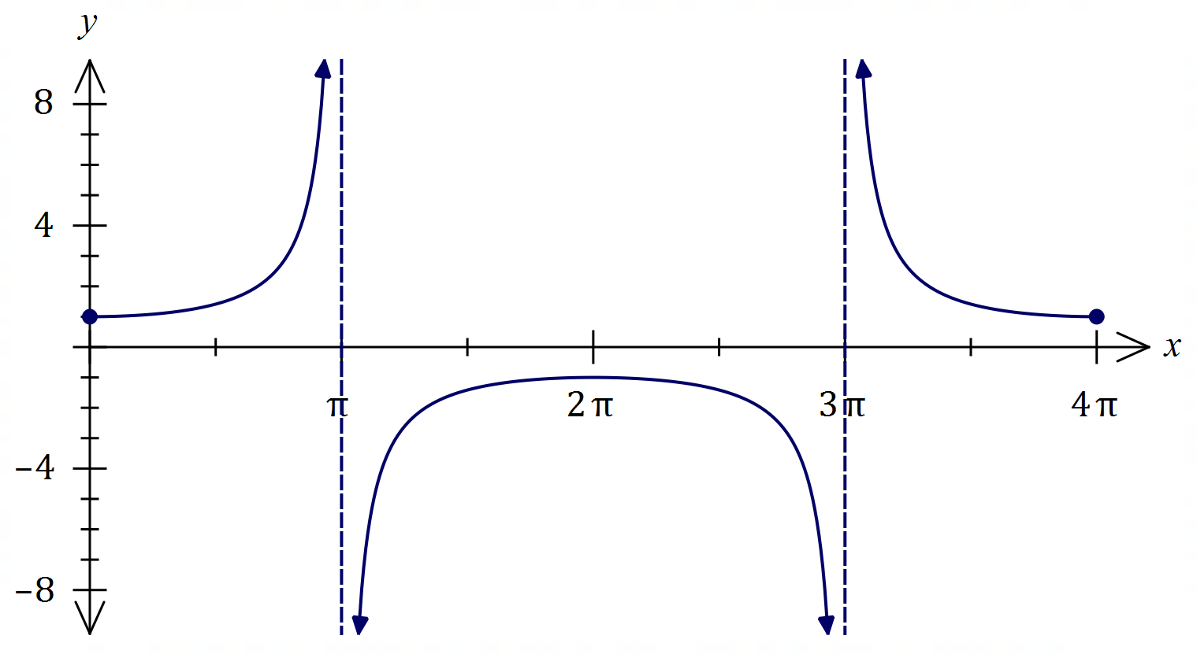
Solution
See graph
Specific behaviours
asymptotes
ü $y$-intercept, max
ü correct curvature

(b) Prove the identity $\operatorname{cosec}{2A}-\cot{2A}=\tan{A}$. (3 marks)
Solution
$$LHS=\operatorname{cosec}{2A}-\cot{2A} \\ =\frac{1}{\sin{2A}}-\frac{\cos{2A}}{\sin{2A}} \\ =\frac{1-\cos{2A}}{\sin{2A}} \\ =\frac{2\sin^{2}{A}}{2\sin{A}\cos{A}} \\ =\frac{\sin{A}}{\cos{A}} \\ =\tan{A} \\ =RHS$$

Specific behaviours
converts between reciprocal and basic trig functions
ü writes as single fraction
ü uses double angle identities and simplifies

Question 3 (6 marks)
Let $z_{1}=\sqrt{5}+3i$ and $z_{2}=\sqrt{5}-i$. Determine each of the following in the form $a+bi$.

(a) $2z_{1}-z_{2}$. (1 mark)
Solution
$$2\sqrt{5}+6i-\left(\sqrt{5}-i\right)=\sqrt{5}+7i$$

Specific behaviours
correct result

(b) $i{\overline{z}}_{1}$. (1 mark)
Solution
$$i\left(\sqrt{5}-3i\right)=3+\sqrt{5}i$$

Specific behaviours
ü correct result

(c) $z_{1}×z_{2}$. (2 marks)
Solution
$$\left(\sqrt{5}+3i\right)\left(\sqrt{5}-i\right)=5+3\sqrt{5}i-\sqrt{5}i+3 \\ =8+2\sqrt{5}i$$

Specific behaviours
correctly expands
ü correct result

(d) $z_{1}÷z_{2}$. (2 marks)
Solution
$$\frac{\sqrt{5}+3i}{\sqrt{5}-i}×\frac{\sqrt{5}+i}{\sqrt{5}+i}=\frac{2+4\sqrt{5}i}{6} \\ =\frac{1}{3}+\frac{2\sqrt{5}}{3}i$$

Specific behaviours
uses conjugate correctly
ü correct result

Question 4 (6 marks)
(a) Determine the value(s) of the constant $t$ given that $\left[\begin{matrix}-2 & 4 \\ t & 8\end{matrix}\right]\left[\begin{matrix}t \\ t\end{matrix}\right]=\left[\begin{matrix}2t \\ 33\end{matrix}\right]$. (2 marks)
Solution
$$t^{2}+8t=33 \\ t^{2}+8t-33=0 \\ \left(t+11\right)\left(t-3\right)=0 \\ t=-11, t=3$$

Specific behaviours
forms quadratic
ü correct values

(b) Determine $A^{-1}$ when $A=\left[\begin{matrix}7 & 3 \\ -2 & 2\end{matrix}\right]$. (2 marks)
Solution
$${\left[\begin{matrix}7 & 3 \\ -2 & 2\end{matrix}\right]}^{-1}=\frac{1}{20}\left[\begin{matrix}2 & -3 \\ 2 & 7\end{matrix}\right]$$

Specific behaviours
indicates determinant
ü correct inverse

(c) Show use of matrix methods to solve the following system of linear equations:

$$7x+3y-25=0 \\ 2y-2x+10=0$$
(2 marks)
Solution
$$\left[\begin{matrix}7 & 3 \\ -2 & 2\end{matrix}\right]\left[\begin{matrix}x \\ y\end{matrix}\right]=\left[\begin{matrix}25 \\ -10\end{matrix}\right]$$

$$\left[\begin{matrix}x \\ y\end{matrix}\right]=\frac{1}{20}\left[\begin{matrix}2 & -3 \\ 2 & 7\end{matrix}\right]\left[\begin{matrix}25 \\ -10\end{matrix}\right] \\ =\left[\begin{matrix}4 \\ -1\end{matrix}\right]$$

Specific behaviours
writes as matrix equation
ü shows use of inverse and obtains correct solution

Question 5 (6 marks)
(a) Using a product identity, or otherwise, evaluate $\sin\left(\begin{matrix}5π \\ \overline{12}\end{matrix}\right)+\sin\left(\begin{matrix}π \\ \overline{12}\end{matrix}\right)$. (3 marks)
Solution
$$\sin\left(\frac{5π}{12}\right)+\sin\left(\frac{π}{12}\right)=\sin\left(\frac{3π+2π}{12}\right)+\sin\left(\frac{3π-2π}{12}\right) \\ =2\sin\left(\frac{3π}{12}\right)\cos\left(\frac{2π}{12}\right) \\ =2×\frac{\sqrt{2}}{2}×\frac{\sqrt{3}}{2} \\ =\frac{\sqrt{6}}{2}$$

Specific behaviours
indicates appropriate sum and difference
ü uses identity
ü evaluates

(b) Solve the equation $2\sin^{2}{2x}=3\cos{2x}, 0≤x≤2π$. (3 marks)
Solution
$$2\left(1-\cos^{2}{2x}\right)-3\cos{2x}=0 \\ 2\cos^{2}{2x}+3\cos{2x}-2=0 \\ \left(2\cos{2x}-1\right)\left(\cos{2x}+2\right)=0 \\ \cos{2x}=\frac{1}{2} \\ 2x=\frac{π}{3},\frac{5π}{3},\frac{7π}{3},\frac{11π}{3} \\ x=\frac{π}{6}, \frac{5π}{6}, \frac{7π}{6}, \frac{11π}{6}$$

Specific behaviours
uses Pythagorean identity to form quadratic
ü factors quadratic and indicates one solution
ü all correct solutions

Question 6 (7 marks)
(a) Determine all complex solutions to the equation $z^{2}-10z+27=0$. (2 marks)
Solution
$${\left(z-5\right)}^{2}=25-27 \\ {\left(z-5\right)}^{2}=2i^{2} \\ z=5±\sqrt{2}i$$

Specific behaviours
completes square
ü both correct solutions

(b) $z_{1}=-4-i$ is a solution to $f\left(z\right)=0$, where $f(z)$ is a real quadratic polynomial.

(i) State $z_{2}$, another solution to $f\left(z\right)=0$. (1 mark)
Solution
$$z=-4+i$$
Specific behaviours
correct complex number

(ii) Let $z_{3}=z_{2}-z_{1}$. Plot and label $z_{1}, z_{2}$ and $z_{3}$ in the complex plane below. (2 marks)

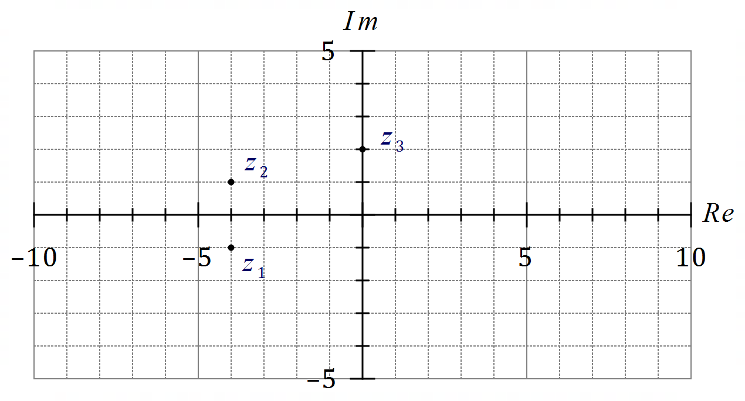
Solution
See graph
Specific behaviours
sketches roots as conjugate pair
ü correctly locates $z_{3}$

(iii) Determine $f(z)$, given that the coefficient of its $z^{2}$ term is $1$. (2 marks)
Solution
Let $f\left(z\right)=z^{2}+bz+c$.
Then $b=-2\left(-4\right)=8$ and $c=4^{2}+1^{2}=17$.

$$f\left(z\right)=z^{2}+8z+17$$

Specific behaviours
shows sum and product of roots (or product of factors)
ü correct equation

Question 7 (6 marks)
Use mathematical induction to prove that $2^{5n}-5^{n}$ is divisible by $9$ for all integers $n≥1$.
Solution
Let $f\left(n\right)=2^{5n}-5^{n}$.

When $n=1$ then
$$f(1)=32-5 \\ =27 \\ =3×9 \text{which is divisible by} 9$$

Assume true for $n=k$ so that $2^{5k}-5^{k}=9I$ for some integer $I$.

When $n=k+1$ then
$$f\left(k+1\right)=2^{5k+5}-5^{k+1} \\ =2^{5}∙2^{5k}-5∙5^{k} \\ =32\left(9I+5^{k}\right)-5∙5^{k} \text{(using assumption)} \\ =32\left(9I\right)+27\left(5^{k}\right) \\ =9\left(32I+3\left(5^{k}\right)\right) \text{which is divisible by} 9$$

Hence $f(n)$ is divisible by $9$ for $n=k+1$ and as demonstrated divisible for $n=1$ then will be divisible for all $n≥1$.

Specific behaviours
demonstrates true for $n=1$
ü makes assumption for $n=k$
ü expression for $f(k+1)$
ü uses assumption to replace $2^{5k}$
ü factors out $9$ from $f(k+1)$
ü concluding statement

Question 8 (8 marks)
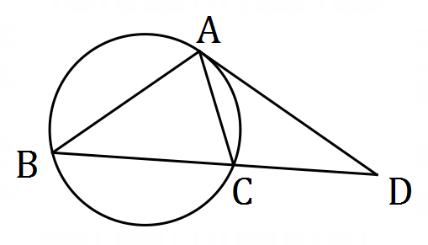
(a) Points $A, B$ and $C$ lie on a circle.
The tangent to the circle at $A$intersects secant $BC$ at point $D$.

Prove that $AD^{2}=BD×CD$. (4 marks)
Solution
First prove that $ΔADC\sim ΔBDA$:

$$∠ADC=∠BDA (\text{common}) \\ ∠DAC=∠DBA (\text{angles in opposite segments})$$

Hence $ΔADC\sim ΔBDA$ as two pairs of congruent angles.

Using ratios of corresponding sides, $\begin{matrix}AD \\ \overline{BD}\end{matrix}=\begin{matrix}CD \\ \overline{AD}\end{matrix}⇒AD^{2}=BD×CD$.

Specific behaviours
shows congruency of one pair of angles, with reasoning
shows congruency of second pair of angles, with reasoning
ü establishes similarity, with reasoning
ü completes proof using ratio of sides

(b) Two unequal circles intersect at $P$ and $Q$. A common tangent touches one circle at $R$ and the other circle at $S$. $PQ$ produced intersects $RS$ at $X$. Prove that $X$ bisects $RS$. (4 marks)
Solution
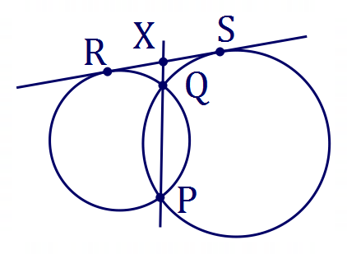
Let $PQ$ and $RS$ intersect at $X$.
In smaller circle, $RX^{2}=XQ×XP$ (tangent secant theorem)
In larger circle, ${SX}^{2}=XQ×XP$ (tangent secant theorem)
Hence $RX^{2}=SX^{2}⇒RX=SX$ and so $PQ$ produced bisects $RS$.

Specific behaviours
labelled diagram
ü uses tangent-secant theorem in one circle
ü uses tangent-secant theorem in the other circle
ü concludes proof

Supplementary page

Question number: _________

© 2021 WA Exam Papers. Kennedy Baptist College has a non-exclusive licence to copy and communicate this document for non-commercial, educational use within the school. No other copying, communication or use is permitted without the express written permission of WA Exam Papers. SN245-181-3.

